AROUND TOWN WITH LAUREN DRUMMOND

SPRING HAS SPRUNG
Yes, indeed, everyone is abound with all the activities, planting, the various finds at the flea market, and all the wonderful things that Spring has to offer. And Whitecliff Vineyards & Winery, a constant supporter of our fest, was no exception has they offered their, “Taste of Spring,” Saturday, March 22, 2014. From 12-5 PM, wine enthusiasts beckoned to the country side of Gardenville, to sample pairing of five of their wines with Mediterranean Lamb Meatballs with Yoghurt Sauce. The tasting took advantage of the great wine pairing potential of lamb to work well with both red and white wines. The lamb was delicious (see recipe below), and the wine samples was
Before that, I ventured to Dutchess Market Place in Fishkill, NY, an indoor flea market, which opened their doors May15, 2014. You will find gems from all over, clothes, antique, jewelry, radios, tv, appliances, food, anything your heart desire. Various people were in and out to purchase the various wares.

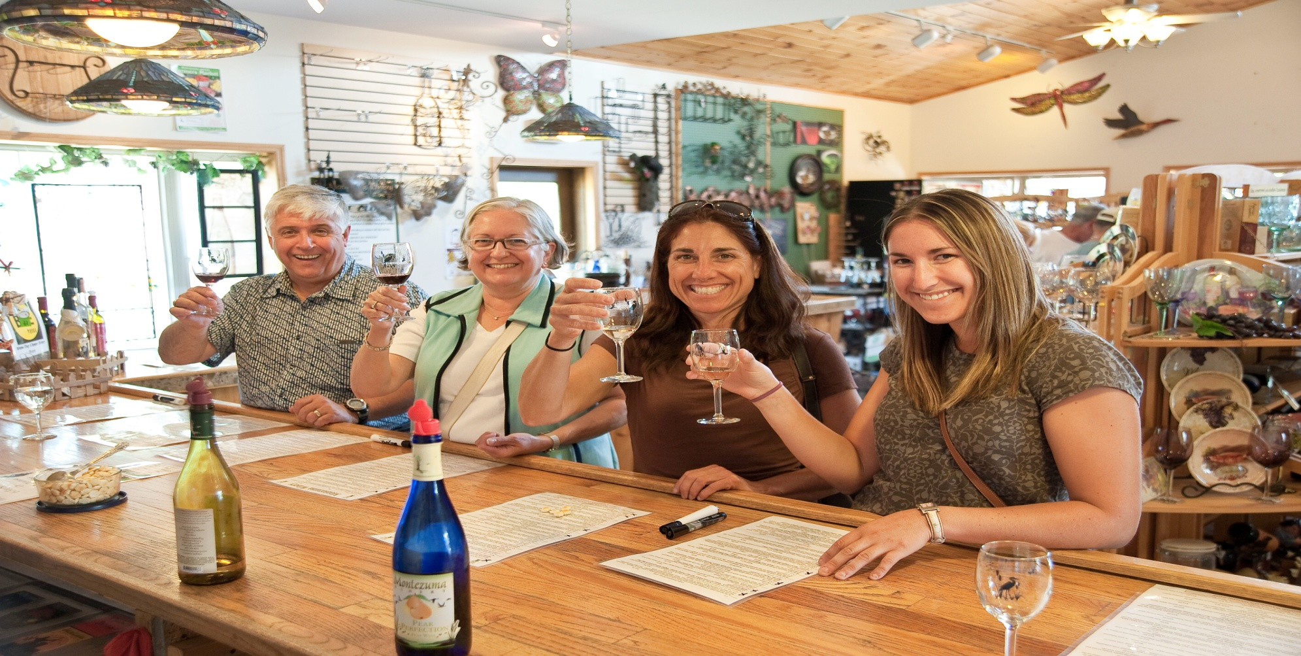
MEET OUR NEWEST VENDOR: An indepth interview with Montezuma Winery:

Will you please tell us about your winery and how you got to where you are today?
For more than thirty years, George Martin had been a bee keeper. George, along with wife, Virginia and son Ed, maintained and built a honey production and pollination business which contained two thousand hives and took place in Maine, New York, Florida and South Carolina.
In 1998 with dropping honey prices and increasing costs the family now with son Bill, began niche marketing their honey. Bill had always dabbled in mead making and home brewing. The Martin Family applied for a farm winery license in 1999 and commercial production of honey wine began. Soon after, Martin’s Honey Farm and Meadery in Sterling, New York was born.
In 2001, the Martin’s realized the importance of their location in the fruit belt of New York and decided to try their hand at making fruit wines. The concept of Montezuma Winery was then formed. Montezuma Winery quickly took off and was a great success, so much so that we moved the production facilities and gift shop to our 14,000 square foot building in Seneca Falls. Although we do produce high quality grape wines, the focus of our product line is still towards fruit and honey wines.
Always looking to expand our offerings, Hidden Marsh Distillery was added in 2008 to feature premium liqueurs, brandy and vodka made with honey, apples, or other seasonal fruits. Custom-built in Germany, our 400-liter Christian Carl column pot still has 2 columns consisting of a 4-plate column for high end brandy production and a 21-plate column for premium vodka production. Being the first of its kind in the Finger Lakes region, each batch is a hands-on process and takes on a more artistic form producing high quality premium spirits.
Montezuma Winery, Martin’s Honey Farm and Meadery and Hidden Marsh Distillery have been awarded numerous awards including Gold, Double Gold, Best of Class, Best Fruit wine, and Commercial Mead Champion. Our wine list offers a range from dry to sweet and include Riesling, Blueberry, Rhubarb and our most popular, Cranberry Bog.
What is unique about your winery?
Located in the heart of the Finger Lakes Region of Seneca Falls, NY and adjacent to the breathtaking Montezuma National Wildlife Refuge, the Martin Family would like to invite you to join them in a tasting of their award winning grape, fruit and honey wines. With a selection of over 30 wines, ranging from dry to sweet, there is something for everyone. Browse through our extensive gift shop filled with a huge selection of the most unique gifts in the area.
What wines do you specialize in?
Fruit, grape, and honey wines
Do you have anything to add?
We opened our new winery, Idol Ridge, in November of 2013. Idol Ridge offers distinctive wines along with a stunning panoramic view of Seneca Lake.

